**Task 6**

We installed Karamel tool in our Linux-based local system. Also, we created RSA pair keys on our local system. Before enabling Compute Engine’s OAuth 2.0, we created a service account named darkferi and generated a json key file for this service account. After that, we started Karamel and loaded the provided cluster definition. Then we launched the cluster definition by providing our RSA keys and json key to the Karamel (Figure 1). We waited for 3 VMs to be launched and connected (Figure 2).

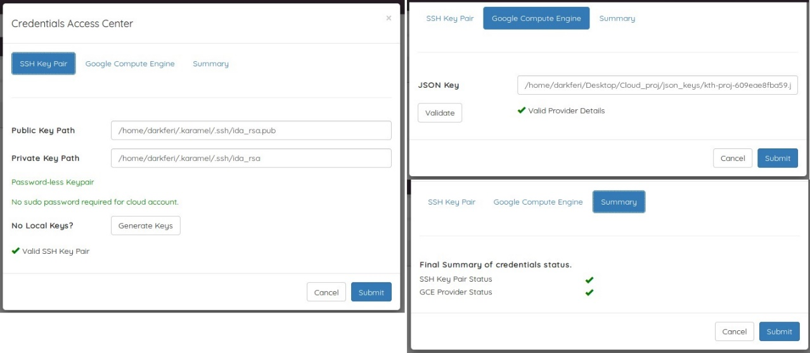

Figure 1: Launching Cluster Definition

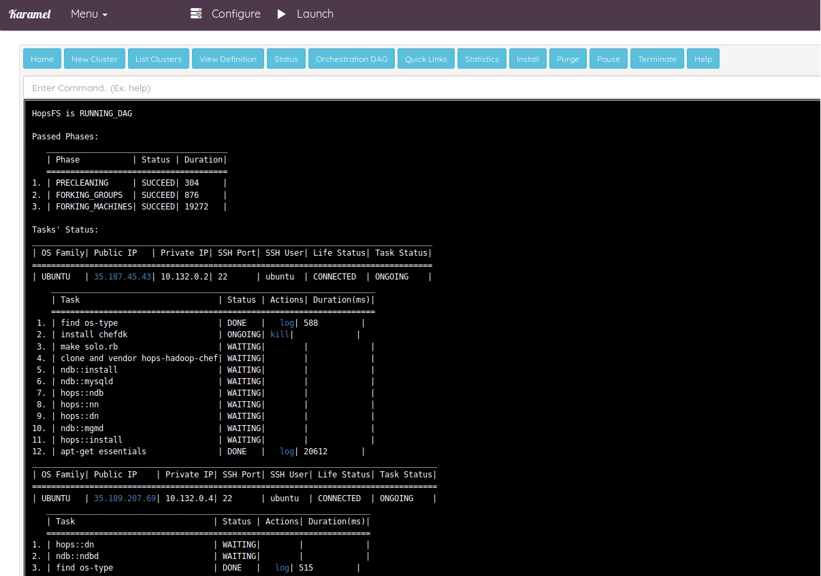

Figure 2: Karamel is launching 3 VMs (VMs are connected)

In the next step, we used the provided Helper code to create our download and upload jar file by changing Main.java file and calling the appropriate functions. In the following you can find a lin to Main.java code in our github:

<https://github.com/haha150/cloud/tree/master/task6/hops/src/main/java/se/kth/hops/main>

Then, we created 1GB file using *fsutil* and used *scp* to send the file to the VM (private IP: 10.132.0.2) with the rate of 31.0 MB/s (Figure 3). Also by using *scp*, we sent our jar files to the same VM (Figure 4).



Figure 3: Sending 1 GB file from local system to VM created by Karamel

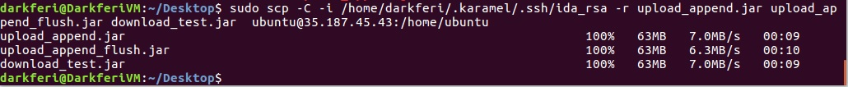

Figure 4: Sending three jar files from local system to the VM created by Karamel

In the VM, first, we checked that there is no file named */dark/darkfile* in HopsFS. Second, we tried to upload 1 GB file to HopsFS using upload_append.jar. It took 7s for the VM to upload the file into HopeFS. Third, we tried to download the uploaded file using download_test.jar after checking that our upload attempt was successful (/srv/hops/hadoop/bin/hdfs dfs -ls /dark/darkfile). We checked the VM file system and figured that the download attempt was successful too. It took 5s for the VM to download 1 GB file from HopeFS. In the end, we removed our file from HopeFS and tried to upload this 1GB file again, but this time, we used upload_append_flush.jar and surprisingly the result was like upload attempt without flush. It also took 7s for the VM to upload 1GB file into HopeFS (Figure 5).

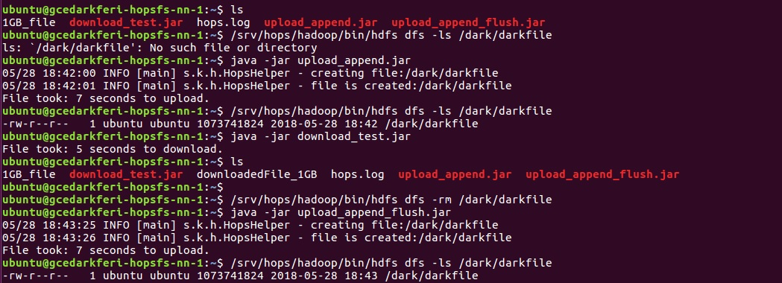

Figure 5: Testing three jar files, HopeFS, and benchmarking in VM